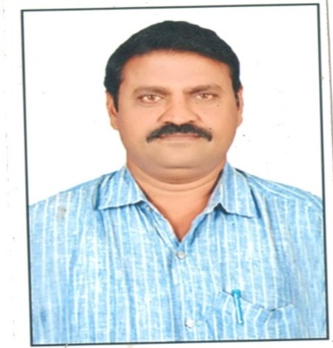
PROFILE OF THE FACULTY

Name : Dr. K. SREENIVASA REDDY
Fathers Name : K. Narayana Reddy
D.O.B : 01-06-1973
Date of Joining : 02-09-2002
CFMS ID : 1000093041
Mobile No : 9441656390
E-Mail ID : kataru1973@gmail.com
Designation : Contract Lecturer in History
Department : History
Educational Qualifications : M.A., M. Phil., Ph. D
Professional Experience in
Different Capacities : 21Years
Date of Joining in this college: 08-07-2022, GDC Jammalamadugu
Scale of Pay : 61,960/-
Aadhaar No : 793760629877
PAN Card No : BNNPS3027G

COURSE | INSTITUTION | BOARD /  UNIVERSITY | YEAR OF  COMPLETION | AGGREGATE  (%)
Ph.D | Potti Sriramulu Telugu University, Srisailam | Potti Sriramulu telugu University, Hyderabad. | 2015 | __
M.Phil | Potti Sriramulu Telugu University, Srisailam | Potti Sriramulu telugu University, Hyderabad. | 2000-2001 | 62%(Gold Medal with Certificate)
M.A. History | S.K. University, Anantapuram | S.K. University, Anantapuram | 1995-97 | 56.5%
B.A. (H.E.P) | SKSC Arts College, Proddutur. | S.V University Tirupati. | 1990-93 | 58.5%
Intermediate | Govt. Junior College, Jammalamadugu | Board Of Intermediate Education, Hyderabad. | 1988-90 | 52.5%
SSC | Govt. Junior College, Porumamilla | Board Of Secondary Education, Hyderabad. | 1988 | 73%

POSITION | Experience
Degree College Lecturer | 21Years
TECHNICAL EXPERTISE
  - TYPEWRITING ENGLISH HIGHER, TELUGU HIGHER.

INTERESTS
Reading Books, Social Service

CERTIFICATIONS
- Participated in A.P History congress, Srisailam – 2015 (Topic-Rajampeta Taluka Grama Kyifiyats.)
- Participated in A.P History congress, KVR College Women, Kurnool – 2020 January (Topic– Kurnool district Grama Kyifiyats)
- Article published Vangmai Magazine, Hyderabad Title-Araveeti Dynasty, Owk Chiefs-(2014 July-September)
- Certified for Passing in Type Writing.
- Participated in Faculty Development Programme organised by CCE (Title-Teaching Methods) Date-2020 5th July
- Participate in FDP organised by CCE.(Title-Innovative Techniques in Teaching History) Date-28-03-2022
- Participated and presented a paper on “Kurnool District Palegars” in A.P. History Congress at Yogi Vemana University, Kadapa held at 7th & 8th January, 2023.
Research Activity: Awarded Ph.D.

